A\*

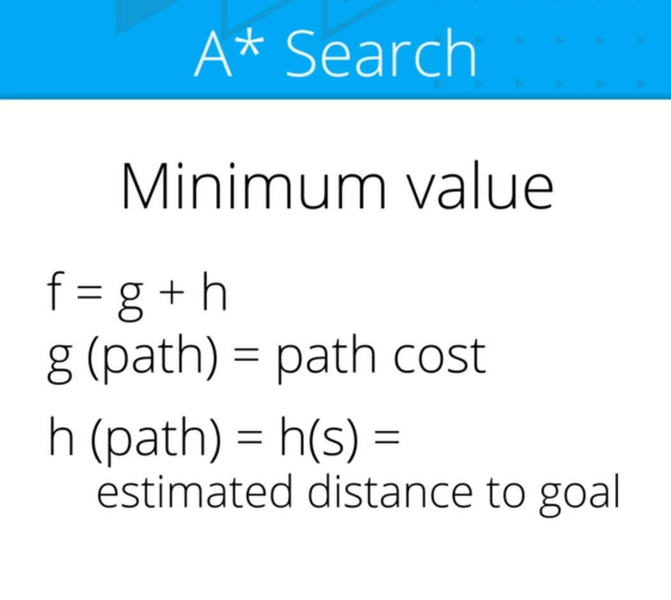



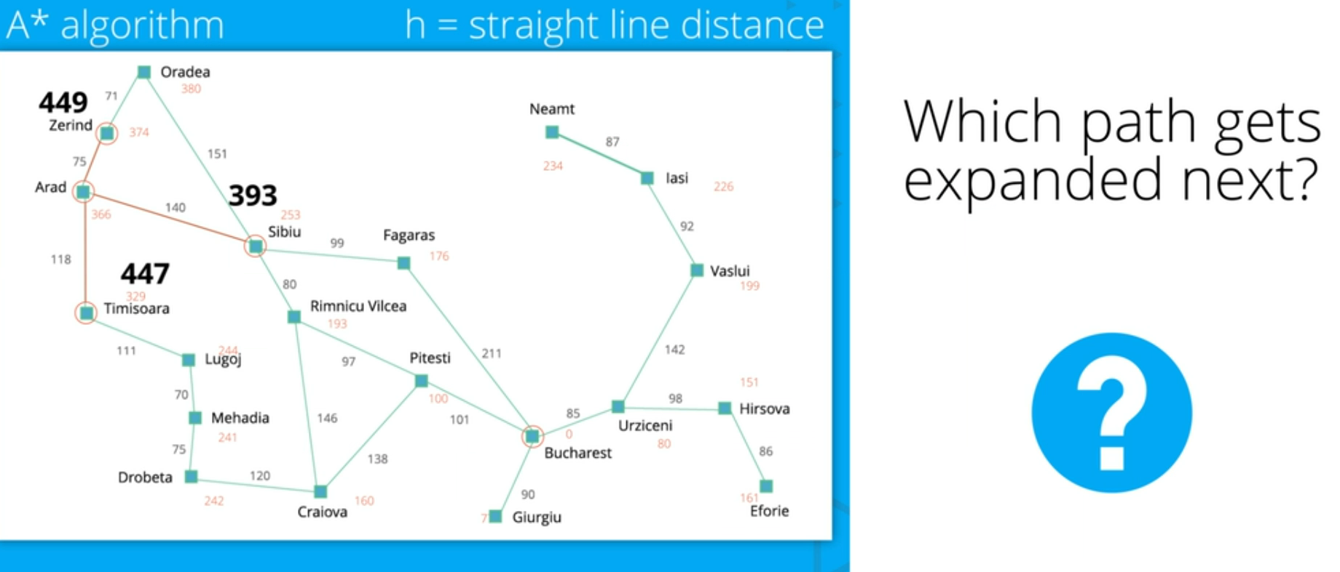

Red is estimate

F = g + h

Path Path Cost (g) Est. Distance (h) Total (f)

Arad >> Zerind 75 374 449

Arad >> Sibiu 140 253 393

Arad >> Timisoara 118 329 447

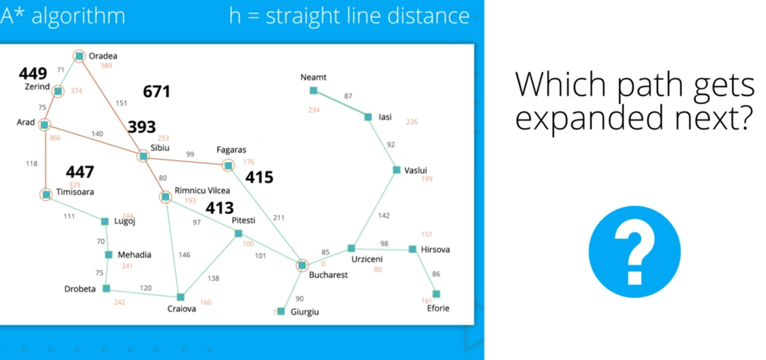

Path Path Cost (g) Est. Distance (h) Total (f)

Arad >> Zerind 75 374 449

Arad >> Sibiu >> Oradea 291 380 671

Arad >> Sibiu >> Fagaras 239 176 415

Arad >> Sibiu >> Rimnicu Vilcea 220 193 413

Arad >> Timisoara 118 329 447

Note that the path costs here add up together (i.e. Arad >> Sibiu >> Oradea is 140 + 151 = 291), while the estimated distance is given only from the current end node of the path.

Rimnicu Vilcea and Fagaras hardly increased in total value under \large ff even though they added 80 and 99, respectively, in path cost, as their estimated distance to the goal decreased. Since they are much more in the specific direction of our goal of Bucharest, the search space is much more inclined to expand to them under A\*, similar to greedy best-first search.

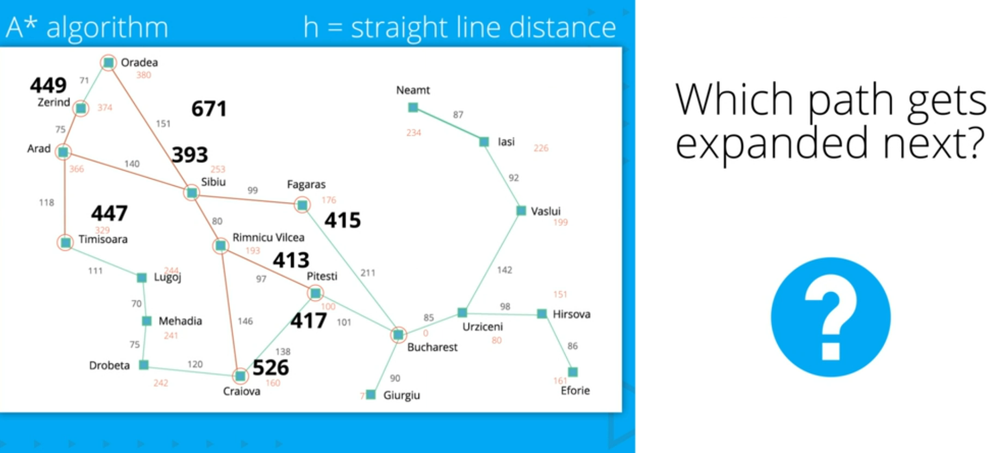

Path Path Cost (g) Est. Distance (h) Total (f)

Arad >> Zerind 75 374 449

Arad >> Sibiu >> Oradea 291 380 671

Arad >> Sibiu >> Fagaras 239 176 415

Arad >> Sibiu >> Rimnicu Vilcea >> Pitesti 317 100 417

Arad >> Sibiu >> Rimnicu Vilcea >> Craiova 366 160 526

Arad >> Timisoara 118 329 447

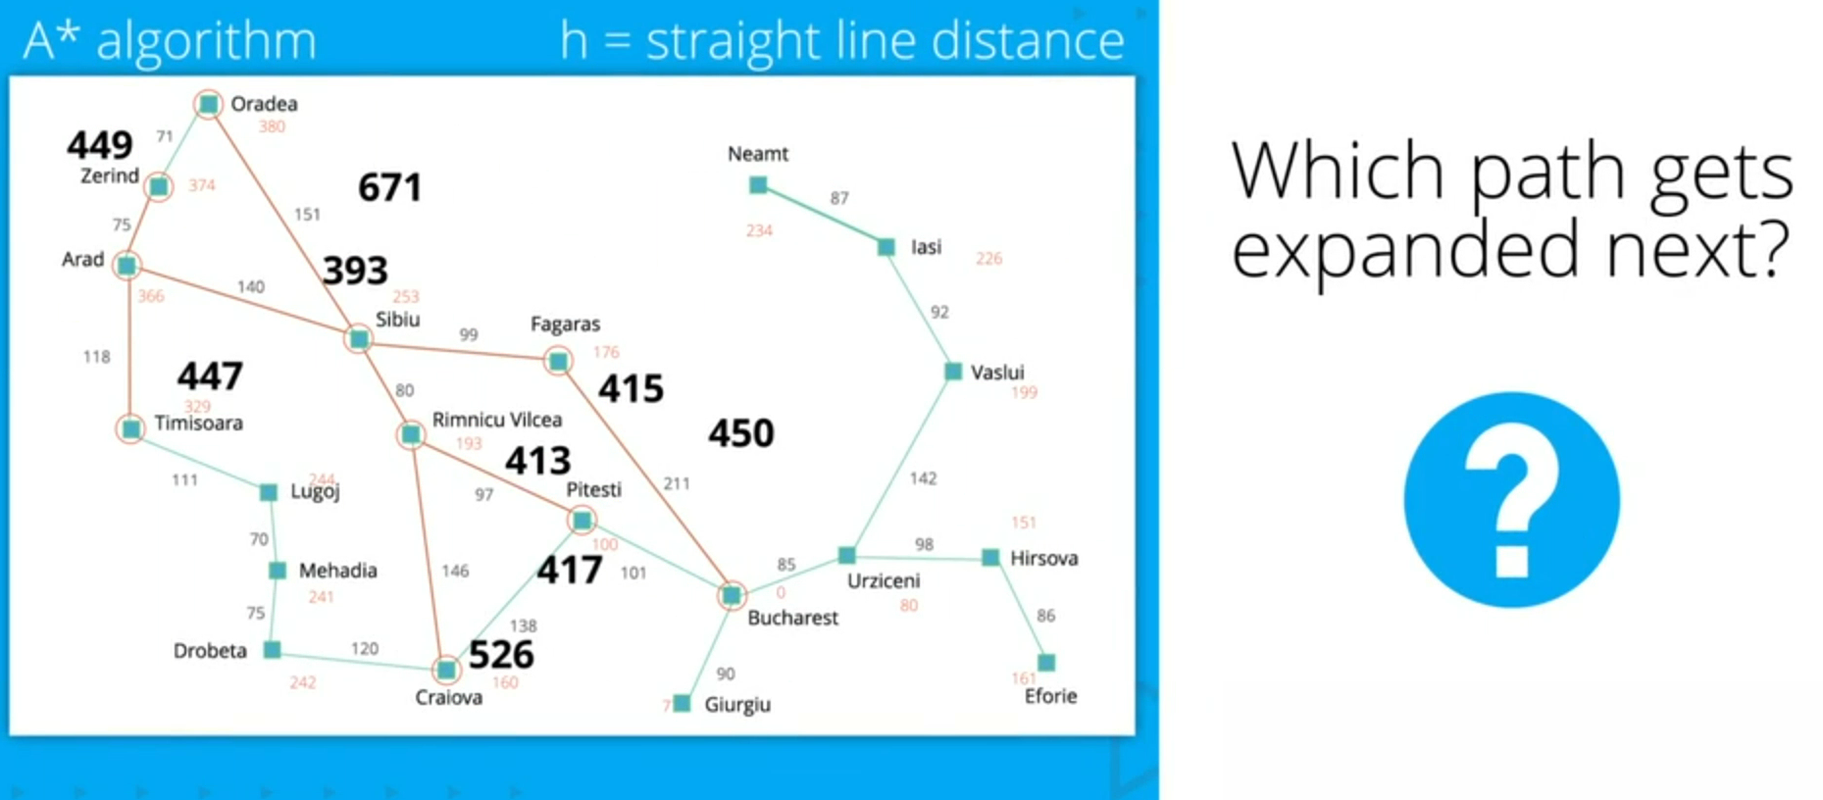

Path Path Cost (g) Est. Distance (h) Total (f)

Arad >> Zerind 75 374 449

Arad >> Sibiu >> Oradea 291 380 671

Arad >> Sibiu >> Fagaras >> Bucharest 450 0 450

Arad >> Sibiu >> Rimnicu Vilcea >> Pitesti 317 100 417

Arad >> Sibiu >> Rimnicu Vilcea >> Craiova 366 160 526

Arad >> Timisoara 118 329 447

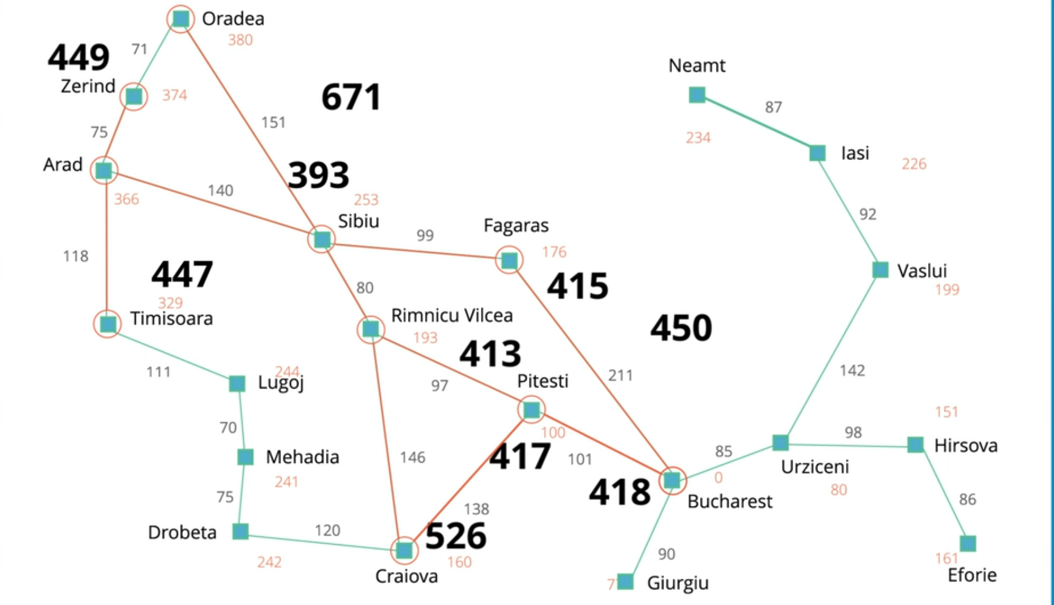

Path Path Cost (g) Est. Distance (h) Total (f)

Arad >> Zerind 75 374 449

Arad >> Sibiu >> Oradea 291 380 671

Arad >> Sibiu >> Fagaras >> Bucharest 450 0 450

Arad >> Sibiu >> Rimnicu Vilcea >> Pitesti >> Bucharest 418 0 418

Arad >> Sibiu >> Rimnicu Vilcea >> Craiova 366 160 526

Arad >> Timisoara 118 329 447

There are no additional paths with lower totals, so the path with \large ff of 418 is our shortest path.

Will A\* always find the shortest cost path?

No, it depends on the heuristic estimate function h

